Clustering Countries for Strategic Aid Allocation

Problem statement:

HELP International is an international humanitarian NGO that is committed to fighting poverty and providing the people of backward countries with basic amenities and relief during the time of disasters and natural calamities.

HELP International have been able to raise around $ 10 million. Now the CEO of the NGO needs to decide how to use this money strategically and effectively. So, CEO has to make decision to choose the countries that are in the direst need of aid. Hence, your Job as a Data scientist is to categorise the countries using some socio-economic and health factors that determine the overall development of the country. Then you need to suggest the countries which the CEO needs to focus on the most.

Data description
- Country: Name of the country
- Child_mort: Death of children under 5 years of age per 1000 live births
- Exports: Exports of goods and services per capita. Given as %age of the GDP per capita
- Health: Total health spending per capita. Given as %age of GDP per capita
- Imports: Imports of goods and services per capita. Given as %age of the GDP per capita
- Income: Net income per person
- Inflation: The measurement of the annual growth rate of the Total GDP
- Life_expec: The average number of years a new born child would live if the current mortality patterns are to rem...
- Total_fer: The number of children that would be born to each woman if the current age-fertility rates remain th...
- Gdpp: The GDP per capita. Calculated as the Total GDP divided by the total population.

All features are numeric type: 7 floats and 2 integers. After checking the data central tendency, I was able to confirm the dataset contained valid data:
- Average life expectancy: 70.5 years
- Average child mortality rate (per 1,000 live births): 38.3 children
- Median fertility rate: 2.4 children
- Average income: 17,145 USD

Importing libraries:

import os
import pandas as pd
import matplotlib.pyplot as plt
import numpy as np
import seaborn as sns
from scipy.stats import boxcox
from sklearn.preprocessing import StandardScaler

Importing dataset:

df = pd.read_csv("Country-data.csv",\ index_col='country')
df.head()
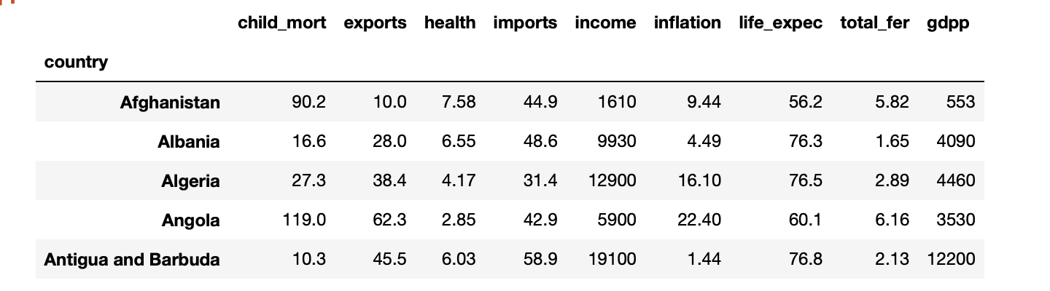

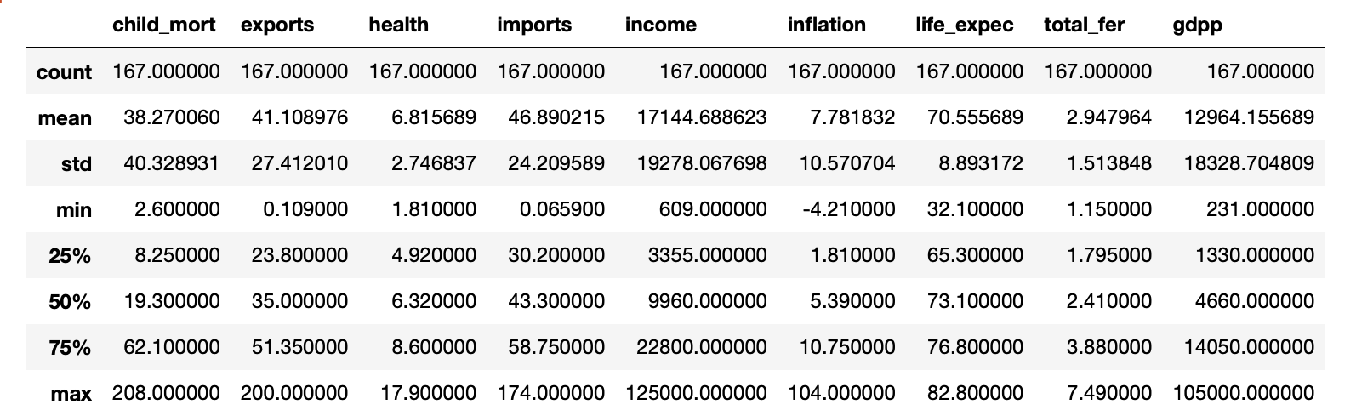
df.describe()

Observations:

After checking general dataset stats, we can confirm the dataset contain valid data:
- Average life expectancy: 70.5 years
- Average child mortality rate (per 1,000 live births): 38.3
- Average fertility rate: 2.9
- Median fertility rate: 2.4
- Average GDP per capita: 12,964 USD
- Average Income: 17,145 USD

Data Cleaning:

# Looking for missing values
for col in df.columns:
print('{} - missing Values: {}'.format(col, df[col].isnull().sum()))

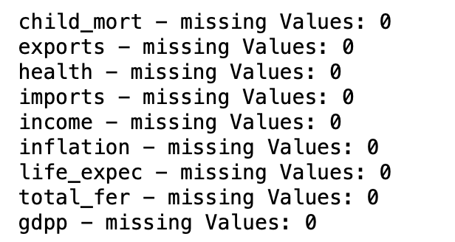
# Looking for outliers
def outlier_visualizer(col, vert=True, grid=True):

(df[col].plot(kind='box',vert=vert))
plt.title('{} - Boxplot'.format(col))
plt.ylabel('Values')
plt.grid(grid)
plt.show()

def outlier_finder(col):
q1 = np.percentile(df[col], 25)
q3 = np.percentile(df[col], 75)
iqr = q3 - q1
left_lim = q1 - iqr*1.5
right_lim = q3 + iqr*1.5
outliers = {'country':[], col:[]}

for i,c in enumerate(df[col]):
if c < left_lim:
outliers['country'].append(df[col].index[i])
outliers[col].append(c)
elif c > right_lim:
outliers['country'].append(df[col].index[i])
outliers[col].append(c)

outliers_df = pd.DataFrame(outliers)
outliers_df.set_index('country', inplace=True)

print('{} - % of outliers: {}%'.format(col, round(outliers_df.shape[0]/df.shape[0]*100,2)))
return outliers_df

fig = plt.figure(figsize=(18,12))
child_mort = fig.add_subplot(3,3,1)
exports = fig.add_subplot(3,3,2)
health = fig.add_subplot(3,3,3)
imports = fig.add_subplot(3,3,4)
income = fig.add_subplot(3,3,5)
inflation = fig.add_subplot(3,3,6)
life_expec = fig.add_subplot(3,3,7)
total_fer = fig.add_subplot(3,3,8)
gdpp = fig.add_subplot(3,3,9)

df['child_mort'].plot(kind='box', fontsize=12, ax=child_mort)
child_mort.grid(True)
df['exports'].plot(kind='box', fontsize=12,ax=exports)
exports.grid(True)
df['health'].plot(kind='box', fontsize=12,ax=health)
health.grid(True)
df['imports'].plot(kind='box', fontsize=12,ax=imports)
imports.grid(True)
df['income'].plot(kind='box', fontsize=12,ax=income)
income.grid(True)
df['inflation'].plot(kind='box', fontsize=12,ax=inflation)
inflation.grid(True)
df['life_expec'].plot(kind='box', fontsize=12,ax=life_expec)
life_expec.grid(True)
df['total_fer'].plot(kind='box', fontsize=12,ax=total_fer)
total_fer.grid(True)
df['gdpp'].plot(kind='box', fontsize=12,ax=gdpp)
gdpp.grid(True)

fig.suptitle('Data Features - Boxplot Analysis', fontsize=16)
plt.tight_layout(pad=2)
plt.show()

Exploratory Data Analysis

Some variables are on a very different scale; before modelling, I'll normalize the data to bring all variables on the same scale to avoid the features with the highest scale to dominate the clustering algorithms.
Let's look into the distribution and feature correlation of our data.

sns.pairplot(df)
plt.show()

Distribution¶
Some of the features seem to be quite right-skewed:
- child_mort
- exports
- imports
- income
- inflation
- total_fer
- gdpp
1 feature seem to be left-skewed:
- left_expec
The remaining features seem to have a more or less normal distribution:
- health

Model Development

# import the libraries
from sklearn.cluster import KMeans
from sklearn.cluster import AgglomerativeClustering
from sklearn.cluster import DBSCAN
from scipy.cluster import hierarchy
from sklearn.metrics import silhouette_score
from sklearn.decomposition import PCA

K-means ¶
Let's fit a K-Means algorithm, fitting the model on a number of clusters that goes from 2 to 10.
I use k-means++ as a smarter initialization method.
I record the Inertia and the Distortion for per each K-value, and plot the number of clusters vs the error, applying the elobw rule to choose the optimum number of clusters.
- Inertia is defined as: the sum of the intracluster distances where an intracluster distance is the sum of squared distances from each point to its cluster centroid.
- Distortion is defined as: the average of the mean squared distance from each point to the centroid of the respective clusters (I create a function, the distortion_function(), to calculate the Distortion)

Using all data features:

def distortion_function(k, dataset, init='k-means++', random_state=98, n_init=10):
km = KMeans(init=init, n_clusters=k, random_state=random_state, n_init=n_init)
km.fit(dataset)
dist_matrix = pd.DataFrame(columns=['Cluster', 'Distance'])
for x in range(len(dataset)):
dist_matrix = pd.concat([dist_matrix, pd.DataFrame({'Cluster': [km.labels_[x]], 'Distance': [((dataset[x] - km.cluster_centers_[km.labels_[x]])**2).sum()]})], ignore_index=True)
distortion = (dist_matrix.groupby(['Cluster']).mean()).mean()[0]
return distortion

inertia = []
distortion = []
silhouette = []

for k in range(2,11):
km = KMeans(init='k-means++', n_clusters=k, random_state=98, n_init=10)
km.fit(scaled_ds)
inertia.append(km.inertia_)
distortion.append(distortion_function(k=k, dataset=scaled_ds, n_init=10))
silhouette.append(silhouette_score(scaled_ds, km.labels_))

#plt.figure(figsize=(8,5.5))
plt.plot(range(2,11), inertia)
plt.scatter(range(2,11),inertia, color='red')
plt.title('Number of Clusters vs Inertia')
plt.xlabel('Number of Clusters')
plt.ylabel('Inertia')
#plt.xticks(ticks=range(2,11), labels=range(2,11))
plt.grid(True)
plt.annotate('Inflection Point: K=3',
xy=(3.05,745),
xytext=(7,850),
arrowprops = dict(arrowstyle='->', connectionstyle='arc3', color='orange', lw=2))
#plt.annotate('',
# xy=(5.05,600),
# xytext=(9,790),
# arrowprops = dict(arrowstyle='->', connectionstyle='arc3', color='orange', lw=2))
plt.show()

Not easy to locate an elbow point. Maybe a kind of an elbow when k=3.
Let's check the Distortion rate.

#plt.figure(figsize=(8,5.5))
plt.plot(range(2,9), distortion[:7])
plt.scatter(range(2,9),distortion[:7], color='red')
plt.annotate('Inflection Point: K= 5',
xy=(5.05,3.5),
xytext=(5.4,4.6),
arrowprops = dict(arrowstyle='->', connectionstyle='arc3', color='orange', lw=2))
plt.title('Number of Clusters vs Distortion')
plt.xlabel('Number of Clusters')
plt.ylabel('Distortion')
#plt.xticks(ticks=range(2,11), labels=range(2,11))
plt.grid(True)
plt.show()

Again, not easy to find the elbow, however I'd say probably when k=5 (or k=4).
Based on the Inertia/Distortion analysis, I'll retrain the model with number of clusters = 3, 4, and 5.
I'll use boxplots as comparison technique to test whether there is significant difference between the clusters, or the clusters overlap with each other and for what variable.
Based on the boxplot analysis, I'll choose the optimum number of clusters to obtain separated (non-overlapping) clusters.

def cluster_boxplots(scaled_dataset, original_dataset, k=2, plot_size=(14,11), add_info=''):
km = KMeans(init='k-means++', n_clusters=k, random_state=98)
km.fit(scaled_dataset)
original_dataset['cluster'] = km.labels_

fig = plt.figure(figsize=plot_size)
child_mort = fig.add_subplot(3,3,1) # or fig.add_subplot(xyz)
exports = fig.add_subplot(3,3,2)
health = fig.add_subplot(3,3,3)
imports = fig.add_subplot(3,3,4)
income = fig.add_subplot(3,3,5)
inflation = fig.add_subplot(3,3,6)
life_expec = fig.add_subplot(3,3,7)
total_fer = fig.add_subplot(3,3,8)
gdpp = fig.add_subplot(3,3,9)

#subplot 1
sns.boxplot(x='cluster', y='child_mort', data=original_dataset, ax=child_mort)
child_mort.set_xlabel(‘')

cluster_boxplots(scaled_ds,bc_data, k=3)

Increase the number of clusters, doesn't provide any better insights for our data (making useless increase the number of clusters):
- When the number of clusters is 4, clusters 0 and 2 significantly overlap.
- When the number of clusters is 5, clusters 0, 2 and 4 significantly overlap.
3 is the greatest number of distinct meaningful clusters we can achieve with K-means, using all data features.

km = KMeans(init='k-means++', n_clusters=3, random_state=98)
km.fit(scaled_ds)
df['cluster'] = km.labels_
print('Pairplot - Number of K-Means clusters (using all data features): 3')
sns.pairplot(bc_data, hue='cluster')
plt.show()

Principal Component Analysis

expl_var = {'N_components':[], 'Explained Variance':[]}

for p in range(2,9):
pca = PCA(n_components=p)
pca_data = pca.fit_transform(scaled_ds)
expl_var['N_components'].append(p)
expl_var['Explained Variance'].append(pca.explained_variance_ratio_.sum())

expl_var = pd.DataFrame(expl_var)
barchart = expl_var.plot(x='N_components', y='Explained Variance', kind='line',figsize=(10,6.5), legend=False)
for i in barchart.patches:
barchart.annotate(round(i.get_height(),3), # get the frequency of the variable categories
xy = (i.get_x() + i.get_width()/2, i.get_height()*1.005), # set the coordinates for each label
ha='center', # set the horizontal alignment
va='top', # set the vertical alignment
xytext=(0,10), # default
textcoords='offset points', # default
fontsize=10) # set the font size
plt.plot(range(-1,10), np.full((11,), 0.9), color='orange')
plt.text(-0.25, 0.92, '90% treshold')
plt.title('Explained Variance by Number of Components')
plt.xlabel('Number of Principal Components')
plt.ylabel('Explained Variance')
plt.xticks(rotation=0)
plt.grid(False)
plt.show()

If we reduce the dimensionality from 9 features to 4 components, we still can maintain more than 90% of the original variance. I choose 4 as number of new components, and retrain the k-means algorithm on the dimension-reduced dataset

DBSCAN ¶
I'll now use on the same dataset (using only the selected features) DBSCAN algorithm to see if I can obtain better results, that is 4 or more than 4 not-overlapping clusters.
I'll train DBSCAN using several values for the following algorithm hyper-parameters:
- the radius of the neighborhood where to look for the cluster points (eps)
- the minimum number of points each observation need to have within the radius distance to be a cluster core point
- Distance metric: Euclidean or Manhatthan distance

radius = np.arange(0.5, 10, 0.05)
min_obs = range(5,61)
distances = ['euclidean', 'manhattan']
dbscan_perf = {'Distance':[], 'Radius':[], 'Min_Points':[], 'N_Cluster':[], 'Silhouette_Coefficient':[]}

for d in distances:
for r in radius:
for m in min_obs:
dbs = DBSCAN(eps=r, min_samples=m, metric=d)
dbs.fit(slct_ds_scld)
#bc_data['cluster'] = dbs.labels_
dbscan_perf['Distance'].append(d)
dbscan_perf['Radius'].append(r)
dbscan_perf['Min_Points'].append(m)
dbscan_perf['N_Cluster'].append(len(np.unique(dbs.labels_)))
try:
dbscan_perf['Silhouette_Coefficient'].append(silhouette_score(slct_ds_scld, dbs.labels_))
except:
dbscan_perf['Silhouette_Coefficient'].append(np.nan)

dbscan_perf = pd.DataFrame(dbscan_perf)

Cluster description

import plotly.graph_objects as go
import plotly.express as px
from sklearn.preprocessing import MinMaxScaler
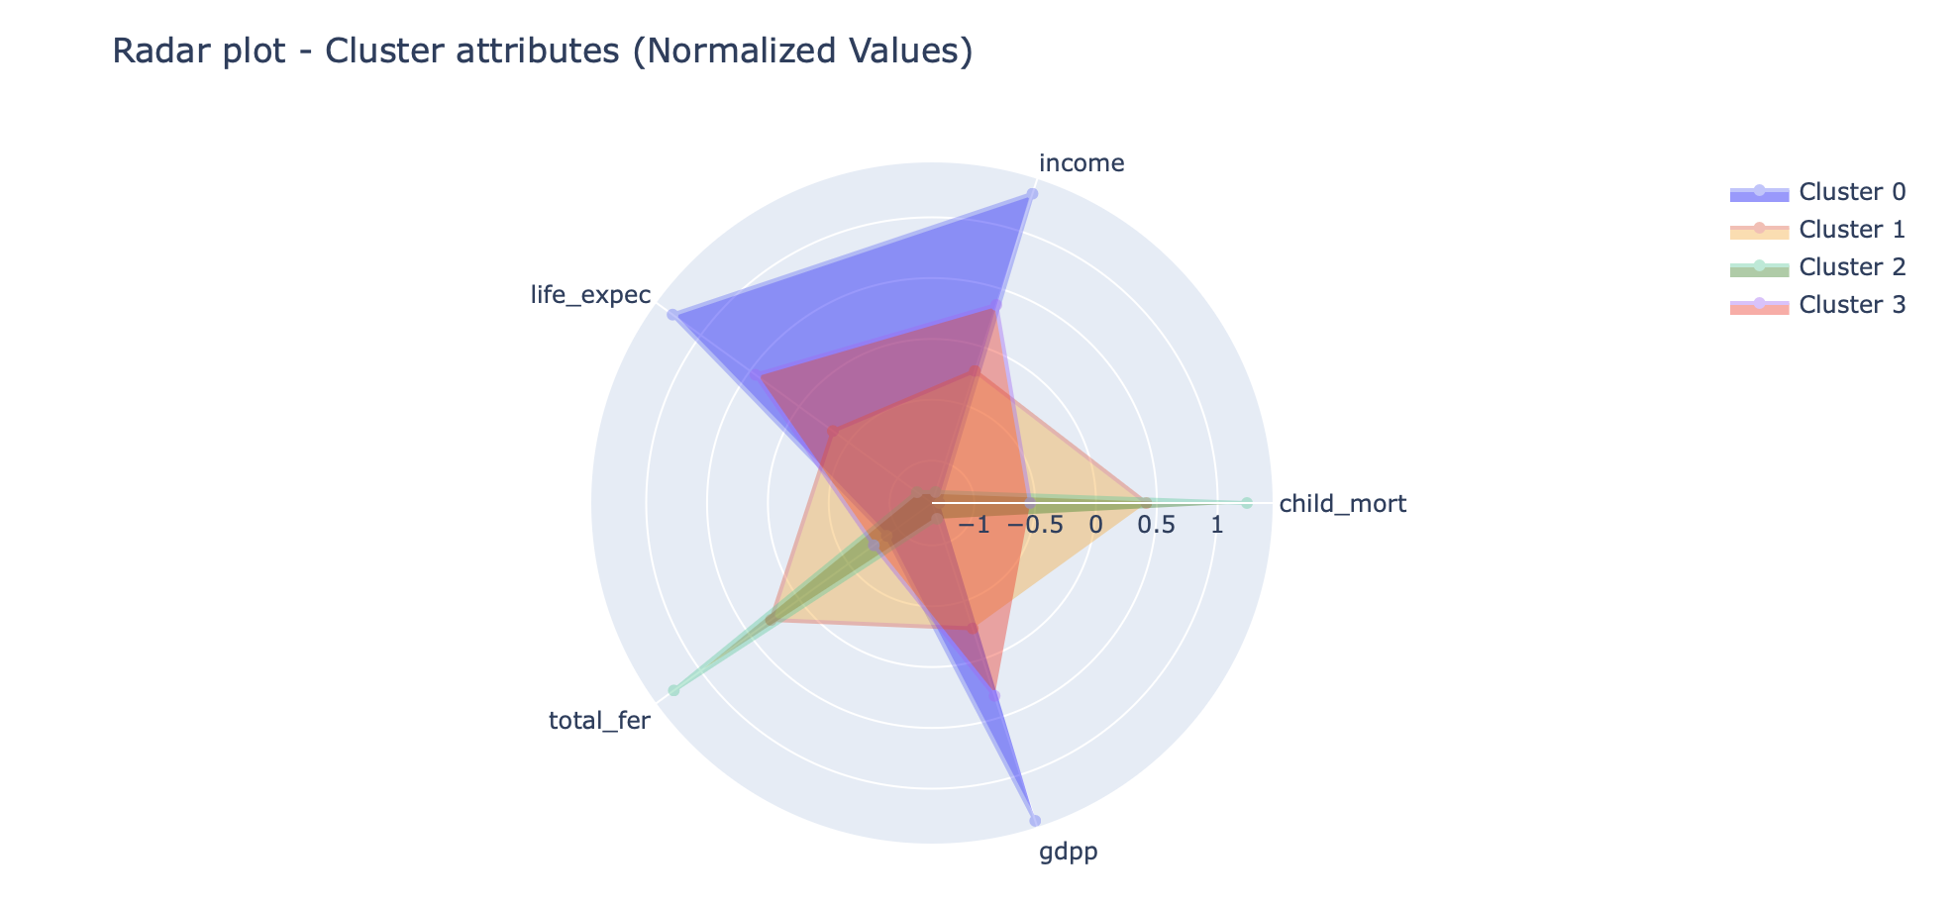

- Cluster 1: countries with the highest values in Income, Life Expectancy, GDP per capita, and lowest values in Child Mortality and Total Fertility. We can label these countries as "Highly developed".
- Cluster 3: these countries have lower values than the Highly Developed observations in Income, Life Expectancy, GDP per capita but still above the overall average. Also have higher values than cluster 1 in Child Mortality and Total Fertility, however below the dataset average. We can label these countries as "Upper-middle developed".
- Cluster 0: countries with Income, Life Expectancy, GDP per capita mean values below the average, and Child Mortality and Total Fertility mean values above the average. We can label these countries as "Lower-middle developed".
- Cluster 2: countries with, by far, the highest values in Child Mortality and Total Fertility as well as the smallest values in Income, Life Expectancy, and GDP per capita. We can label these countries as the "Least developed”.

Potential developments ¶
- It'd be interesting to include in the analysis those countries that weren't included in the dataset.
- As observed, the "Highly Developed Countries" cluster is the only group with a mean positive trade balance. Since Imports and Exports were not included in the selected features to train the model, it'd be interesting to perform Hypothesis Testing Analysis to assess whether the difference between Highly Developed countries' trade balance and the population average is statistically significant or not.
- Include more significant features could help cluster the countries in more distinct groups, providing more insights into the data.
- Record countries data and perform this type of analysis on a periodical basis will be very useful to record countries' change of status over time, and what drove that change.

